**INDIAN AGRICULTURE CROP PRODUCTION**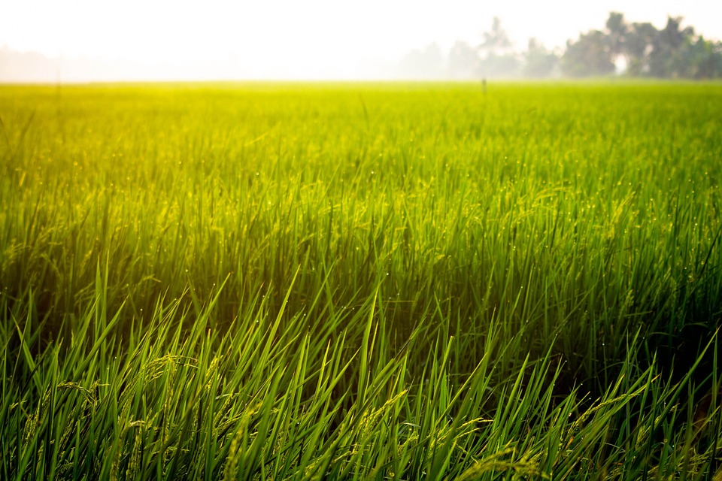

**1.INTRODUCTION**

**1.1.Overview**

**India’s Agricultural Crop Production Analysis**

**(1997-2021)**

* **This report into the captivating realm of India’s agricultural cultivation, providing a comprehensive visual exploration of key aspects and trends in the agricultural sector. Through the visual representations, readers can gain valuable insights into crop production, seasonal variations, regional distribution and overall production trends. These visualizations enable intuitive analysis, allowing stakeholders to uncover patterns, identify areas of growth or concern, and make data-driven decisions.**
* **It provides employment opportunity to the rural agricultural as well as non-agricultural labourers. It is the source of food and fodder. It is also plays an important role in international business in import and export activities.**
* **Crop production is a common agricultural practice followed by worldwide farmers to grow and produce crops to use as food and fibre.**

**1.2.Purpose**

* **Agriculture is the foundation of the Indian economy. Supporting livelihoods through food, habitat, and jobs; providing raw materials for food and other products; and building strong economies through trade.**

**2.PROBLEM DEFINITION & DESIGN THINKING**

**2.1 Empathy Map**

* **Empathy Mapping is a team process that helps you to identify the thoughts and feelings of a particular group-usually customers-on a specific issue.**

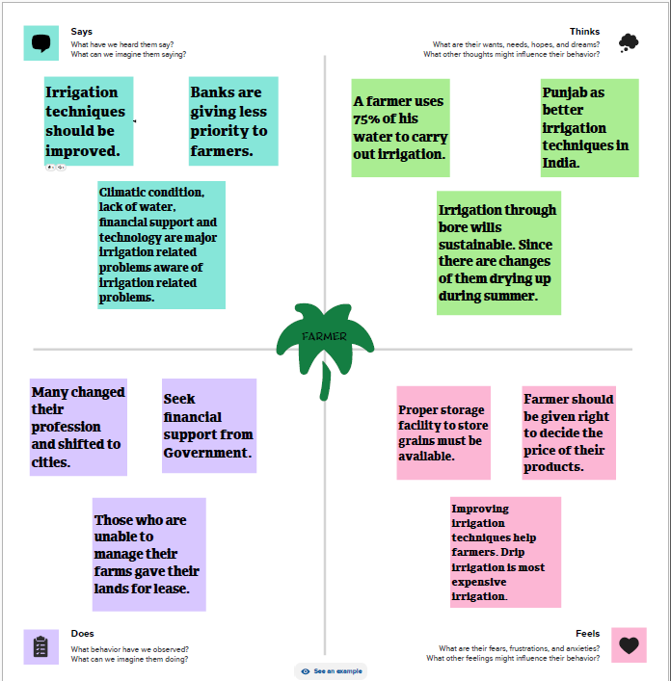

**2.2 IDEATION & BRAINSTORMING MAPPING**

* **Brainstorming is a group problem-solving method that involves the spontaneous contribution of creative ideas and solutions.**

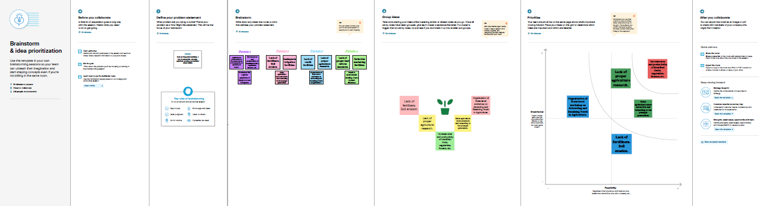

**3.RESULT**

**3.1.Data collection & Extraction**

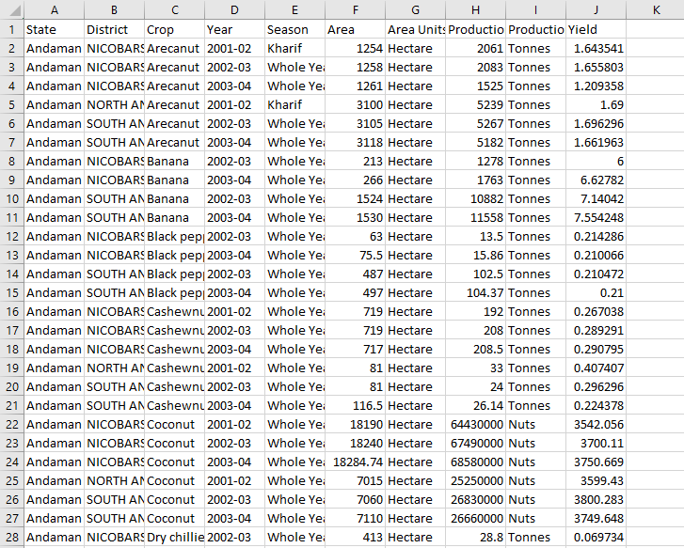

**3.2.Connect Dataset with Tableau**

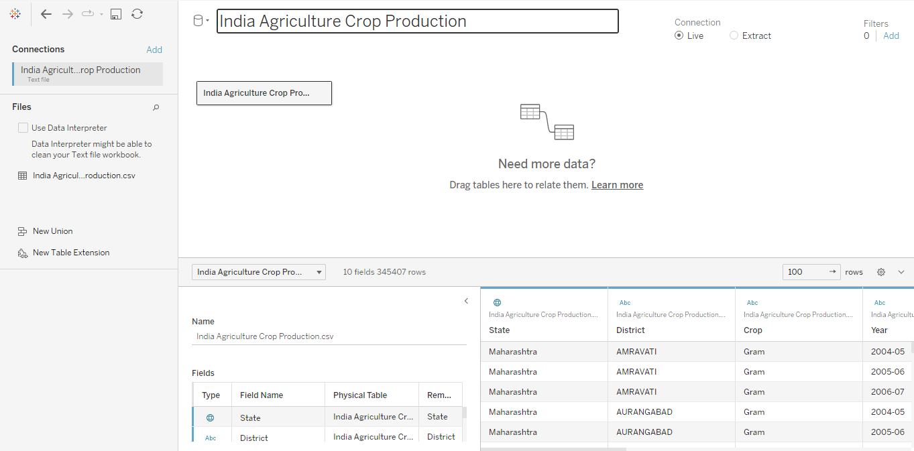

**3.3.DATA VISUALIZATION**

* **State wise Agricultural Land**
* **Area vs Production**
* **Season based cultivation**
* **Yield by season**
* **Crop plantation by area**
* **Major crops growth**
* **Crops**
* **Season wise production**

**DASHBOARD 1**

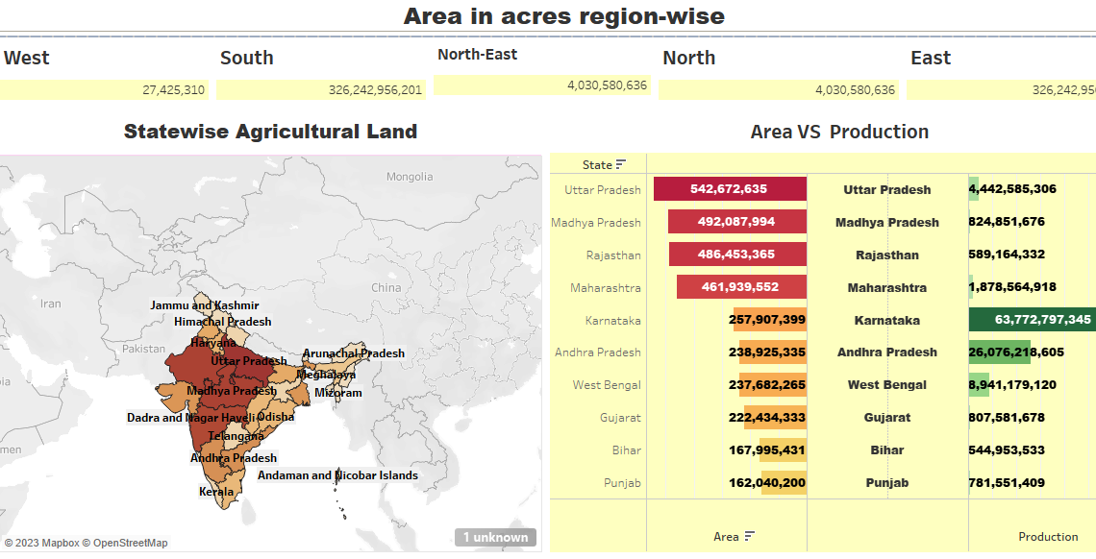

**DASHBOARD 2**

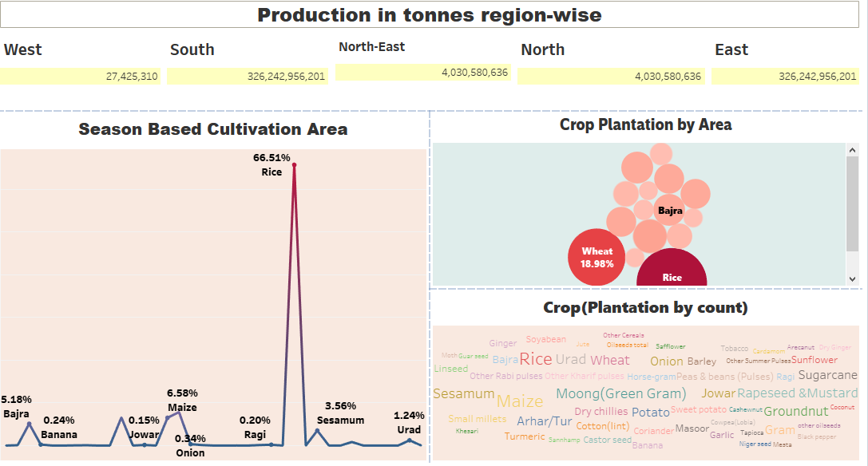

**DASHBOARD 3**

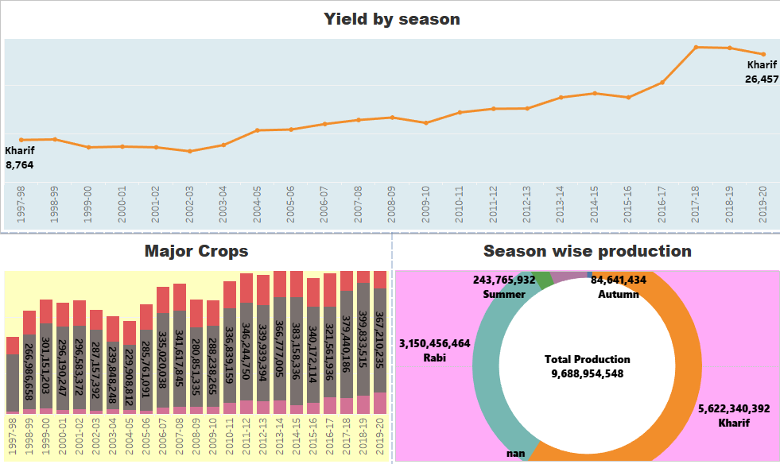

**STORY**

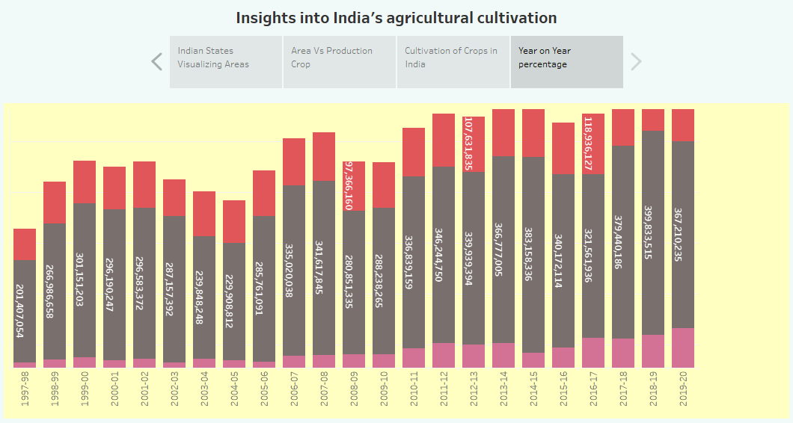

**4.ADVANTAGE & DISADVANTAGE**

**ADVANTAGES:**

* **Develop strong relationships**
* **Low start up costs**
* **Operation receives money upfront**
* **Good margins**
* **Flexible for the grower**
* **Higher average order size**
* **Popular and growing service**
* **Consistent revenues**

**DISADVANTAGES:**

* **Small sector**
* **Administration heavy**
* **Additional costs**
* **Customer service heavy**
* **Large customer turnover**
* **Profits are small**

**5.APPLICATIONS**

* **Agriculture Land Monitoring**
* **Crop Area Estimation & Production Forecast**
* **Agriculture Drought Assessment & Monitoring**
* **Horticulture ture Crop Area Estimation & Monitoring**
* **Cropping systems Analysis**
* **Command Area & Water Resources Monitoring**
* **Inland Fishery Development**

**6.CONCLUSION**

* **Being an agrarian country, agricultural sector of Pakistan’s economy is still backward. Use of modern techniques, provision of credit facilities, basic infrastructure and agriculture research facilities are needed to remove all the problem of agriculture sector.**
* **Though the future of India is industrialiation, the contribution of agriculture would always prove to be vital for making India a powerful & stable economy in the future.**

**7.FUTURE SCOPE**

* **There will be more of vertical and urban farming and there will be also be efforts in long term to find new areas for production like barren deserts and seawater.**
* **Millets are a group of small-seeded grains cultivated for thousands of years in many parts of world. They are a great source of nutrition, high in fibre and rich in vitamins, minerals and proteins.**

**8.APPENDIX**

**SOURCE LINK**

**DATA SET LINK**

**PUBLISHED LINKS**

**DASHBOARD 1**

<https://public.tableau.com/views/DASHBOARD1_16964829837650/Dashboard1?:language=en-US&publish=yes&:display_count=n&:origin=viz_share_link>

**DASHBOAED 2**

<https://public.tableau.com/views/DASHBOARD2_16964830568930/Dashboard2?:language=en-US&publish=yes&:display_count=n&:origin=viz_share_link>

**DASHBOARD 3**

<https://public.tableau.com/views/DASHBOARD3_16964832313020/Dashboard3?:language=en-US&publish=yes&:display_count=n&:origin=viz_share_link>

**STORY 1**

<https://public.tableau.com/views/STORY1_16964833238510/Story1?:language=en-US&publish=yes&:display_count=n&:origin=viz_share_link>

**STORY 2**

<https://public.tableau.com/views/STORY2_16964842383610/Story2?:language=en-US&publish=yes&:display_count=n&:origin=viz_share_link>